Resilience Accelerator

Using the right AGVs, companies can strengthen their sustainability and resilience: Automated guided vehicles are among the key technologies in the automation of logistics and industrial plants. The efficiency and resilience of the overall system in which they are integrated depend on their fault-tolerant, reliable operation with high availability. Thanks to their consistently modular design, AGVs from Melkus Mechatronic offer maximum efficiency with minimum downtime, while the dynamic navigation and fleet management software ensures high flexibility and easy adaptability of the system. All of this helps strengthen operational resilience.

Goeming/Salzburg, 15.10.2025 – Driverless transportation systems with AGVs (Autonomous Guided Vehicles) and/or AMRs (Autonomous Mobile Robots) are not an end in themselves. They are purchased to automate internal transport operations. Companies can use them to close existing automation gaps between loading zones, warehouses and production, but also between individual manual workstations, machines or lines. Properly selected and planned, an AGV system can not only strengthen the sustainability of a company in terms of economy and resource consumption, but also its resilience.

Small, light-weight, modular
“Our AGVs are particularly compact and can manoeuvre in the tightest of spaces with a small turning circle,” says Martin Lindner, Martin Lindner, CEO of the independent Austrian AGV manufacturer Melkus Mechatronic. “In more ways than one, this contributes to conserving resources and sustainability as well as strengthening operational resilience.” In addition to the reduced space requirement, the low net mass of the vehicles also lowers their energy consumption. This effect is further enhanced by the recovery of braking energy by means of recuperation. Together with a sophisticated charging management system, this ensures low energy consumption and long operating times with few interruptions for recharging the batteries.

Maximum reliability
The resilience of a company stands and falls with reliable system operation. “We deliver maximum efficiency with minimum downtime,” says Martin Lindner proudly. “Two keys to this are using high-quality materials and mechanical designs that can withstand the rigours of everyday operation.

Another is the fully modular AGV design at the heart of the Melkus philosophy. It eases and accelerates development, maintenance, repair and subsequent adjustments, thus ensuring short downtimes. All key components of Melkus Mechatronic AGVs are designed as self-contained modules. After brief training, these can be replaced on site by customer personnel, quickly and without special tools. This way, operation does not need to be halted until a service technician arrives.

Future-proof through flexibility

The modular, object-orientated vehicle software also enables a dynamic, easily scalable system logic that can grow with the customer's requirements and facilitates troubleshooting and repair. The Sigmatek TCS fleet management system used by Melkus Mechatronic in complete system installations can be maintained and adapted to changing requirements by the customer's own personnel after brief training. The Sigmatek SlamLoc real-time navigation software not only enables short and therefore time and energy-saving routes. It also enables the AGVs to react dynamically to changes in the environment, preventing unplanned downtimes if, for example, parked pallets obscure the contours of the hall.

As part of its forward-looking approach, Melkus utilises open standards such as the VDA 5050 interface, which allows Melkus vehicles to be integrated into existing third-party systems, but also enables Melkus AGVs to be supplemented with vehicles from other manufacturers. “Manufacturer independence in the use of vehicles can also make a significant contribution to the efficiency and resilience of an intralogistics system,” Martin Lindner is convinced.
Image Captions

AGVs from Melkus Mechatronic have a particularly compact design and can manoeuvre in the tightest of spaces with a small turning circle. This contributes to resource conservation and sustainability as well as to strengthening operational resilience through reduced space and energy consumption.  Photo: P. Kemptner | 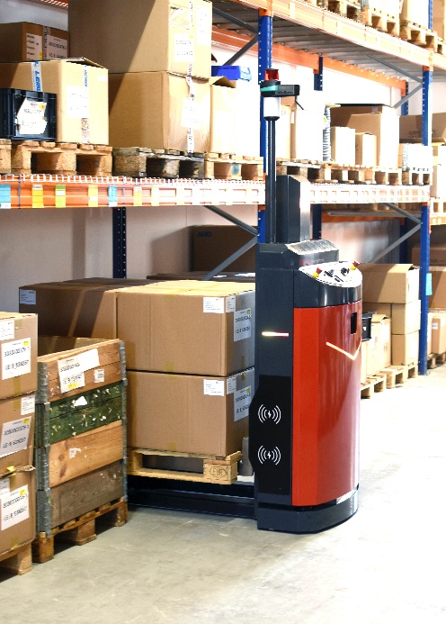
The Sigmatek TCS fleet management system offers an easy-to-use graphical editor for creating customised system layouts and the option of importing real data recorded by AGVs using SLAM navigation in order to adapt the map to existing realities.  Image: Sigmatek | 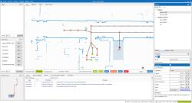
Martin Lindner, CEO, Melkus Mechatronic:  “We deliver maximum efficiency with minimum downtime.”  Photo: A. Glier | 

About Melkus Mechatronic
Melkus Mechatronic GmbH is an innovative technology company based in Salzburg. With more than ten years of experience in the field of AGVs and mobile robotics, it provides customers with highly available AGVs for flexible in-house transport with maximum reliability. Swiftly installed and commissioned, these enable Melkus operators to organise their intralogistics more efficiently and to establish resource-saving processes. Melkus employs highly qualified and committed staff and offers a range of six AGVs for a wide variety of applications. www.melkus-mechatronic.com

